A COMPREHENSIVE ANALYSIS OF FINANCIAL PERFORMANCE :INSIGHTS FROM A LEADING BANKS

INTRODUCTION:

OVERVIEW

The banking industry world-wide is being transformed. The global forces for change include technological innovation; the deregulation of financial services at the national level and opening-up to international competition; and - equally important - changes in corporate behavior, such as growing disintermediation and increased emphasis on shareholder value. In addition, recent banking crises in Asia and Latin America have accentuated these pressures. The banking industries in central Europe and Latin America have also been transformed as a result of privatizations of state-owned banks that had dominated their banking systems in the past. In this project we are trying to analysis the bank related data and able to extract some insights from the data using Business Intelligence tools. To Extract the Insights from the data and put the data in the form of visualizations, Dashboards and Story we employed Tableau tool.

EMPATHY MAP

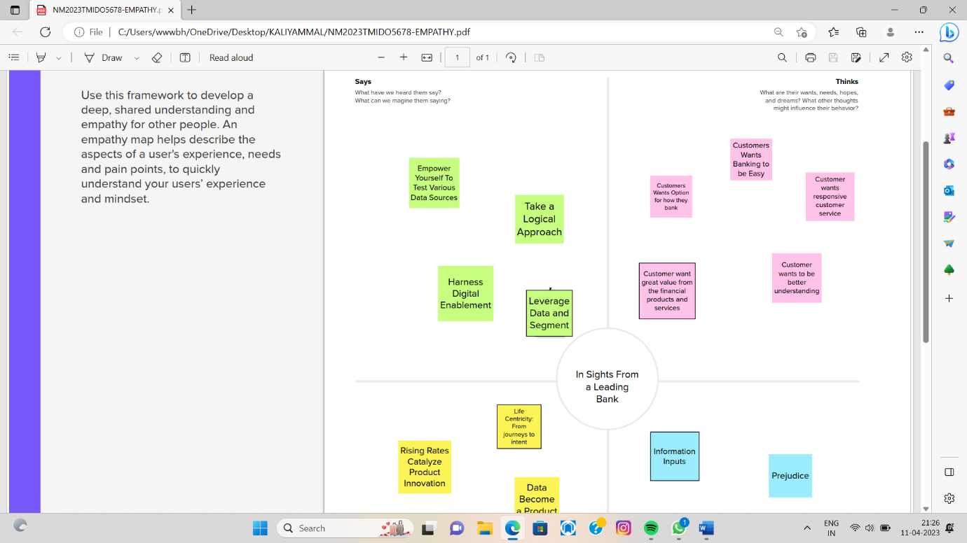

IDEATION& BRAINSTROMING MAPS

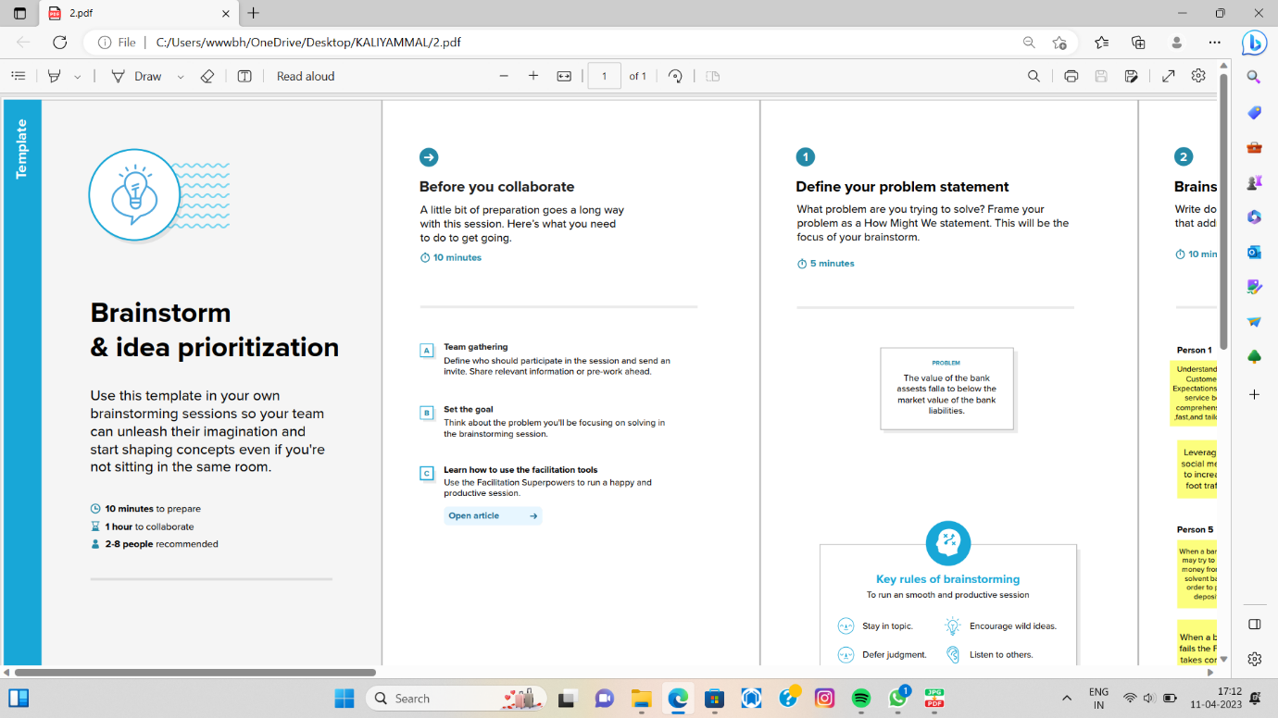

RESULT

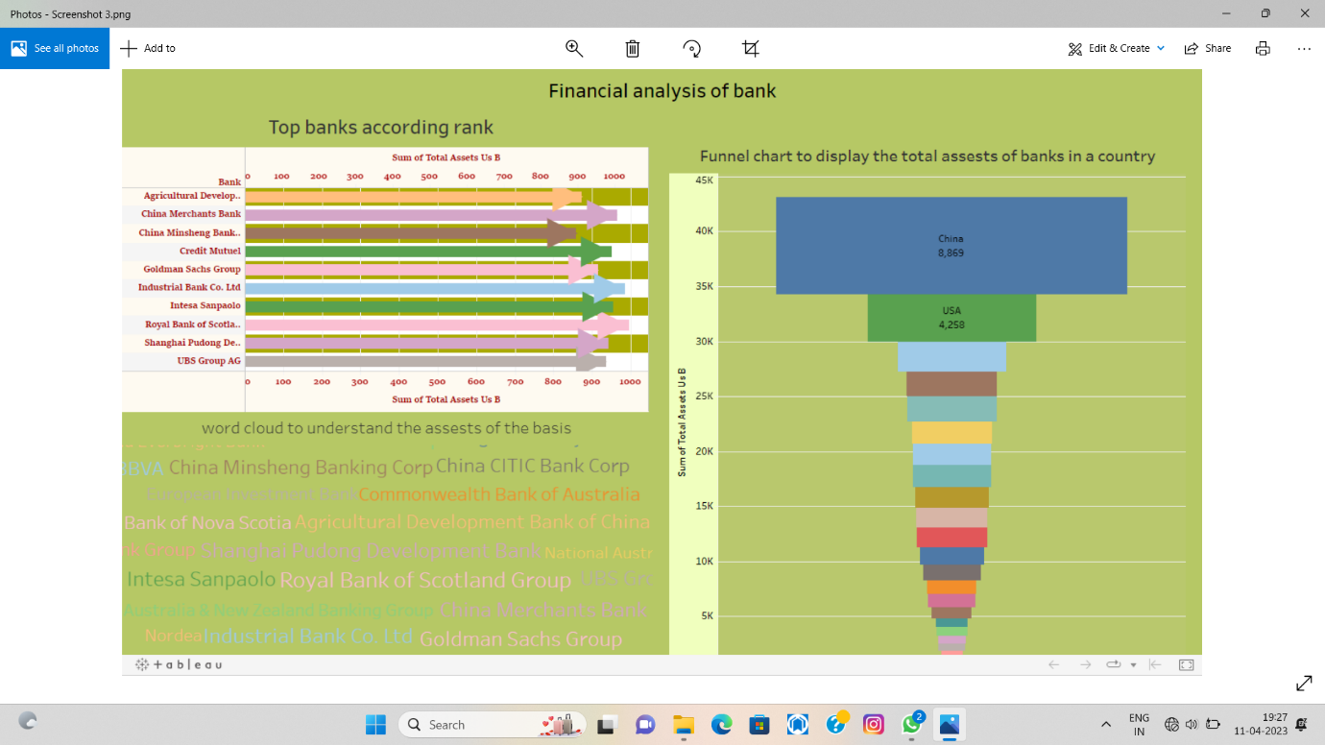

ADVANTAGE

Safely storing the public’s wealth.

Instead of walking around with wads of cash or hiding it under the floorboards, banks provide you with a protected place to store your money without worrying about theft.

DISADVANTAGE

The risk of fraud and robberies.

Online banking is extremely convenient. With the click of a button, you can withdraw or transfer money, set up a new checking account or savings account, or pay your monthly balance off.

Unfortunately, this also means that it’s far easier for another party to access your information. Cybercrime and identity theft have been increasing over the years. Banks have increased their safety precautions and therefore, they also charge customers more money.

CONCLUSION

Banking holds a crucial role in our day-to-day life. We must adhere to the banking system as responsible citizens. The banking system acts as a crucial base for the financial system as well as the entire economic system of the country.